**Name: Pratyusha Chakravarty**

**PROJECT 1:**

**DEPLOYING A WEB SERVER IN WINDOWS INSTANCE**

Task 1: Create a windows instance using AMI :Windows 2012 R2 base

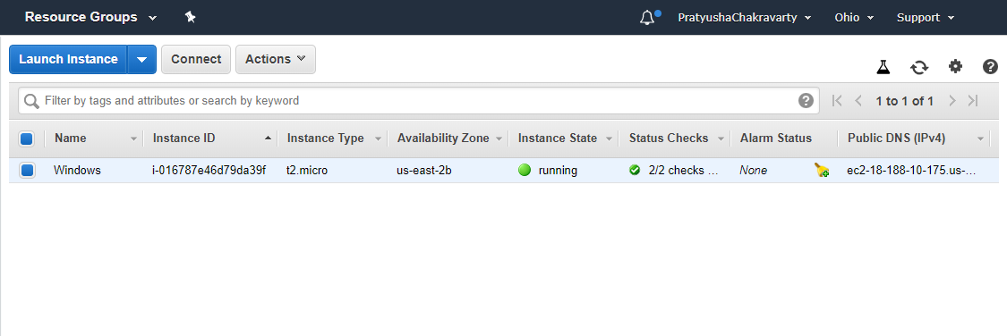

Task 2: Launch the Windows instance using RDP

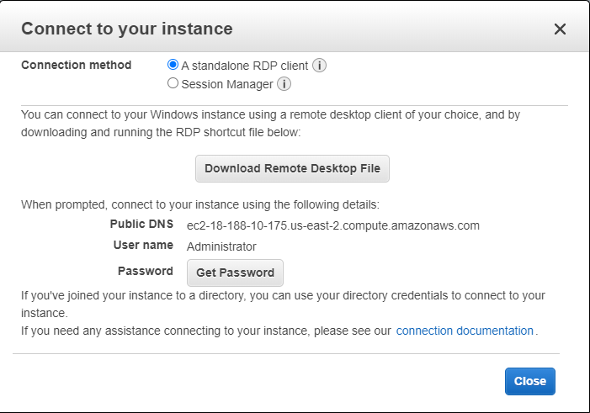

Task 3: Install IIS web server using Powershell ISE Note:Simply copy the command below and paste in the powershell ISE to install the IIS web server. !!!!Powershell is case sensitive. Install-WindowsFeature -name Web-Server -IncludeManagementTools

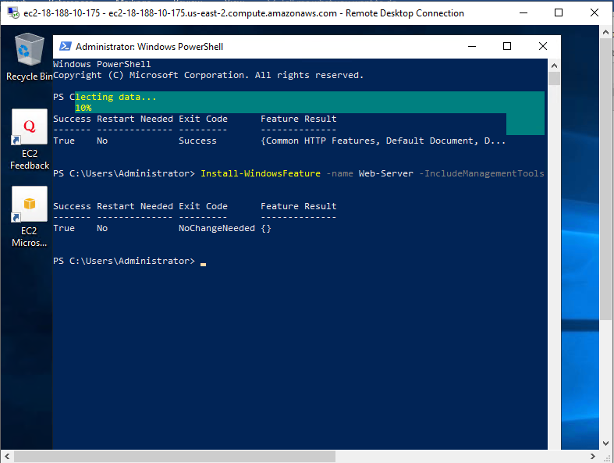

Task 4: Verify successful installation of IIS Web Server Note :You should be able to see the Internet Information Services Web page when you paste the public IP into the browser.

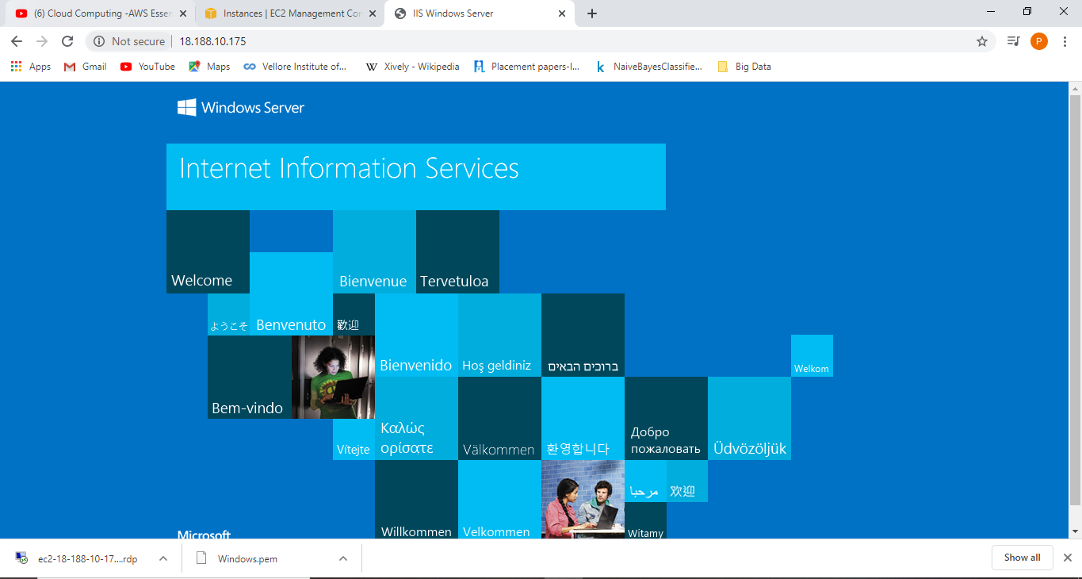

**PROJECT 2:**

**DEPLOYING A WEB SERVER IN WINDOWS INSTANCE**

Task 1: Create a windows instance using AMI :Ubuntu Server 18.04 LTS (HVM)

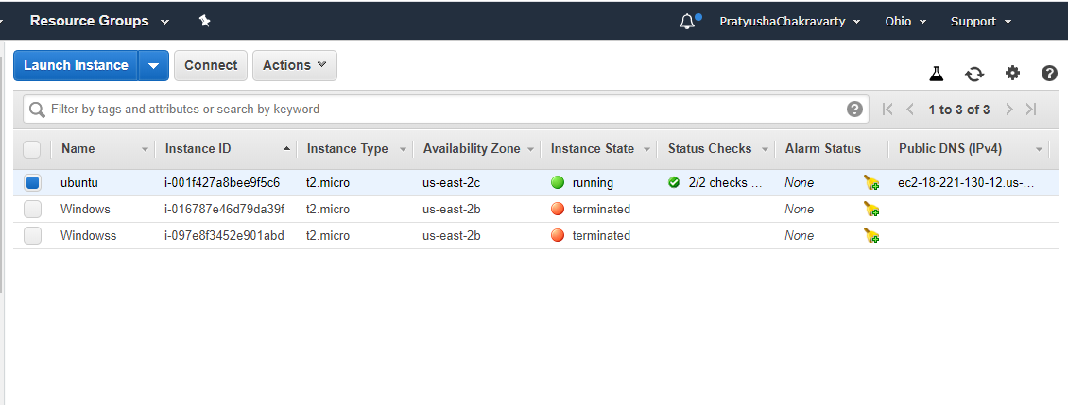

Task 2: Download and install MobaXterm Portable Edition

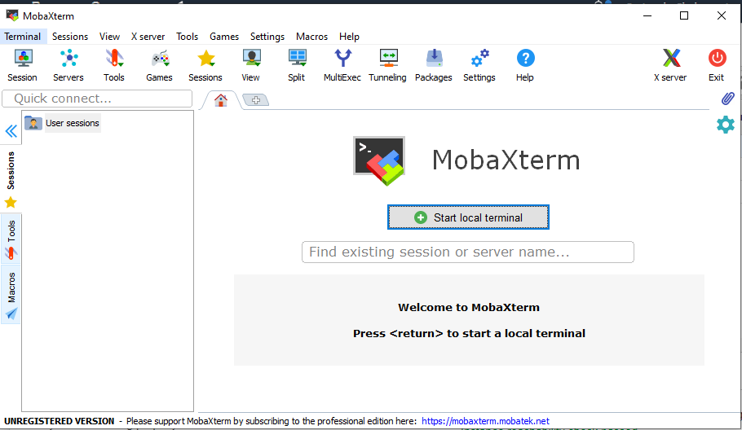

Task 3: Launch the Ubuntu instance using SSH Note:Username is ubuntu

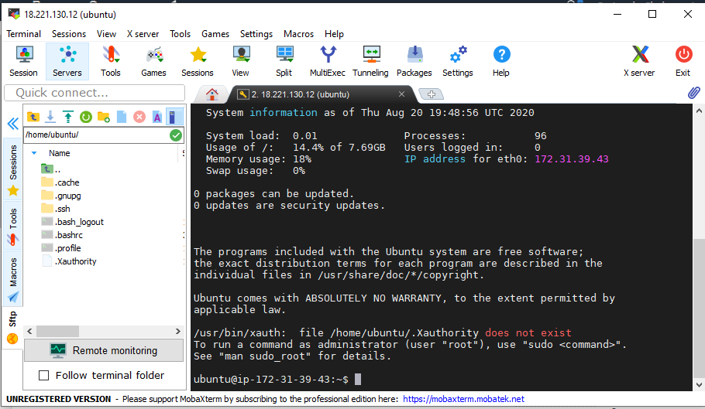

Task 4: Install ngnix web server using bash Note:Simply copy the command below and paste in the bash to install the ngnix web server. sudo apt-get -y update sudo apt-get -y install nginx

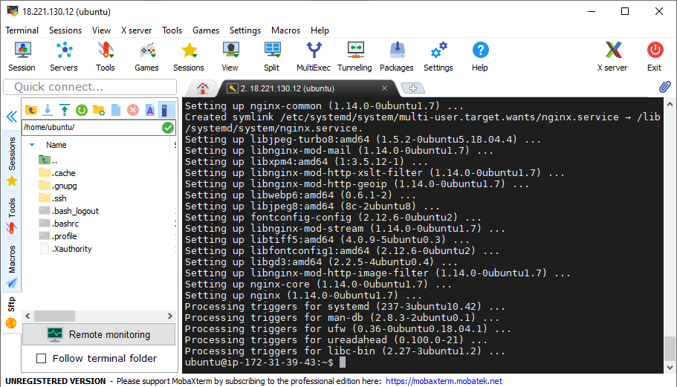

Task 5: Verify successful installation of ngnix Note :You should be able to see the Welcome to ngnix Web page when you paste the public IP into the browser.

